1. **Introduction:**

Pneumonia is an acute disease in Bangladesh, responsible for almost 28% child death under the age of 5 years, which is around 50000 children in number, 2500 a day. 80000 children get admitted to hospital with this viral respiratory disease each year, when total patient counts are much higher [1]. According to WHO, just household pollution is responsible for 4 million premature death each year, around the world, causing pneumonia [2]. The death rate of pneumonia is so high due to wrong or delayed treatment. In common scenario doctors often make mistakes to detect pneumonia on time and the response time for this disease is very narrow, less than two days [3]. So, a fast detecting process is very necessary to ensure proper treatment for a pneumonia patient. Pneumonia is detected by Chest X-Ray, which depends on the availability of expert radiologists or doctor, which leads to a sever chance of mistakes, ignorance and lack of medical resources and personals. A computerized clinical guideline is essential to get rid those situations. We are developing a model to dig up pneumonia from a chest x ray efficiently and precisely.

Deep Neural Network models are usually designed and checked by human experts experimenting them in real time, using trial and error method. A Deep Neural Network Architecture is used to reduce time to optimize classification of recourses which is very crucial for this model. This particular model is designed to classify pneumonia chest x ray images classification tasks using convolution neural network algorithm, processing several related information on a given image and detecting relevant data from it. This model is aimed to reduce the processing cost and time comparing other conventional pneumonia classification processes. Deep learning algorithm, using CNN has become common in medical image classification now a days. CNN exhibit impressive results comparing human examined one. CNN deep learning architecture has two-part, first extraction and input image encoding using convolutional layers CNN and the second one shows a prediction model for the classification task using fully connected neural network classifier. Many hyper parameters including convolutional layers numbers, filters numbers and their respective sizes are optimized by CNN models.

1. **Motivation:**

Pneumonia is the single leading cause of mortality in children under five and is a major cause of child mortality in every region of the world, with most deaths occurring in sub-Saharan Africa and South Asia. Pneumonia kills more children under five than AIDS, Malaria, and measles combined, yet increased attention in recent years have been on the latter diseases. [4]

In Bangladesh, pneumonia is responsible for around 28% of the deaths of children under five years of age. Around 50,000 children die of pneumonia every year. An estimated 80,000 children under five years of age are admitted to hospital with virus-associated acute respiratory illness each year; the total number of infections is likely to be much higher. [5]

Pneumonia kills 4 children every 3hrs in Bangladesh. Bangladesh ranked 14th in the list of total 15 countries who were listed for the high number of deaths due to pneumonia, followed by its South Asian neighbors India, ranked second with 127,000 and Pakistan, ranked third with 58,000 child deaths. Report further stated that pneumonia was the third major cause of child deaths in 2017 in Bangladesh. This infectious disease was responsible for the deaths of four children under five in 1,000 live births in 2018. [6]

Quick diagnosis is key to effective treatment of pneumonia, but this can be difficult. Different medical conditions like excess fluid, internal bleeding, lung cancer, and many others can also show similar opacities in a CXR. [7]

It takes time for a careful review of the CXR, and some clinicians in a short amount of time need to process a large amount of CXRs which is one of the major problems of treatment. The goal of our model is to predict whether a patient has pneumonia so that a clinic can take action as soon as possible and can prevent child from death.

1. **Objective:**

By deep leaning we can easily learn a machine and can have a machine or software or anything related to deep learning or artificial intelligence to overcome our daily life problem.

Our latest studies show that latest improvements in deep learning models with the availability of huge datasets with availability of algorithms taking huge impacts on medical fields which deal with medical images tasks such as skin cancer classification [8], haemorrhage identification [9], arrhythmia detection [10], and diabetic retinopathy detection [11].

So, we build a model which is also deal with medical images. We work on chest X-ray images and build a model to classify those images by deep learning to identify whether pneumonia is present or not which takes a few moments to predict by our model but for doctors and clinic it takes time to identify because this is very complex to identify.

Our theme was to reduce timing problem of identifying this disease because this disease takes a very short time to impact on patient a huge cause most of the patients of this disease is child below 5 years old. If we cannot take action in the very primary stage, we have to pay worse for it. And by overcome this problem, we can reduce the child death from pneumonia of our country. So, here we worked.

1. **Related Works:**

A pneumonia detection system from Chest X-ray images using Supervised Learning was developed by Benjamin Antin, Joshua Kravitz and Emil Martayan [12]. They used NIH dataset, collected from Kaggle which contains 1,12,120 Chest X-ray images of 30,805 unique patients. Their dataset was labelled by different classes like Pneumonia, Fibrosis etc. and Healthy (If the patient has no disease of these classes). They use binary classification to detect from X-ray images whether a patient has one of these diseases or not. After trained the entire dataset using 32*32 dimension as input in their logistic regression, they achieved 0.60 score on AUC curve. Using 128*128 dimension their AUC curve received 0.58 score. Limitation was that model was unable to do a hyper parameter sweep on images larger than 32x32 and 224x224 where they were able to run logistic regression.

In paper [13], we can see, they have built a prototype with Chex Net containing 121-layer of CNN. In this system if an input chest X-ray image is given, the output is going to be the probability of pneumonia in addition to a heat map confining the areas of the image which highly indicate pneumonia. They have used the model Chex Net on ChestX-ray14 dataset containing 112,120 frontal-view chest X-ray images. These images are separately marked with up to 14 non-identical thoracic diseases, including pneumonia. They managed the optimization of this huge deep network using batch normalization and dense connections. There are two limitations in their model.

First one is, only frontal radiographs were submitted to the radiologists and model throughout diagnosis, but to get a proper result up to 15% of precise diagnosis require the lateral view. So, we know that this model can come up with a moderate estimate of performance. Secondly, radiologists and the model itself could not access patient history, as a result the performance in interpreting chest radiographs has decreased. Their Chex Net achieves an F1 score of 0.435 (95% CI 0.387, 0.481).

In [14], they cast pathology detection as a multi-label classification problem. All images X={x→1,…,no }, x→i∈X are associated with a ground truth label y→I, while we seek a classification function f→:X→Y that minimizes a specific loss function l using N training sample-label pairs (x→I, y→i), i = 1 … N. In addition to the original ResNet-50 architecture, they involve two variants: Firstly, they reduce input channels to one (the ResNet-50 is drafted to process RGB images), which should speed up the training of an X-ray specific CNN. Secondly, the input size by a factor of two is increased (i.e. 448 × 448) which keeps the model architectures similar. Here the max-pooling layer used has the same parameters which the “pooling1” layer (i.e. 3 × 3 kernel, stride 2, and padding) has. For an evaluation of the generalization performance, they execute a 5 times re-sampling scheme20. Inside per split, the data is separated into 70% training, 20% testing, and 10% validation.

Without non-image features, the OTS FT 1channel large was 66.4 ± 2.7, 74.4 ± 1.6, 74.3 ± 1.5, 75.3 ± 2.2 and with non-image features it was 68.3 ± 2.3, 73.3 ± 1.3, 74.8 ± 1.5, 76.7 ± 1.5. Their limitation was they present a symentic approach for this problem on ChestX-ray 14 while we think satisfactory result can be obtain in ImageNet. Their model result was satisfactory enough to non-image data while it was not satisfactory in Image data.

In [15], they used an attention-guided mask inference algorithm or AG-CNN to locate salient image regions that stand indicative of pneumonia. They used JSRT dataset which contains 154 modules of lung. The characteristics of local and global network branches in this model are connected in a chain to evaluate the probability of the disease. The AUC reported 0.776 in pneumonia detection. Their accuracy fir ResNet-50 was 0.904 and in DenseNet-121 it was 0.912. Between 14 classes performance was amazing except pneumonia which was .067 which was the lowest performance rate on their proposed model.

In paper [16], we see a Structural Co-occurrence Matrix (SCM) propose to categorize malignant nodules or benign nodules and also their amount of malignancy. The structural o-occurrence matrix technique was applied to extract characteristics of the nodule images and classify them. For extracting features of the nodule images and categorize them, the structural co-occurrence matrix technique was used. Images of the Hounsfield unit was applied with four filters and SCM in gray scale which creates eight different configurations. The categorization stage utilized classifiers like support vector machine, multilayer perceptron, k-Nearest Neighbors algorithm and were used in two tasks (i) to categorize the nodule images as malignant or benign, (ii) to categorize the nodules pulmonary lesions at the amount of malignancy (1 to 5). O (Rodrigues et al., 2018) had an outcome of 96.7 % for F-score measurements and precision in the first task and 74.5 % accuracy and 53.2 % F-score in the second task. Their limitation was in managing over fitting in proposed model. And their F1-score was 54% average while there were some models with only two CNN layers which gives 70% average score. For using high level and different dimension of images to their network the over fitting problem was high enough.

In paper[17], an idea is suggested that shows the change of the right and left lung region as to symmetry and programmed the chest X-ray system for the confirmation of tuberculosis. The suggested system is the study of radiological exams which result in bilateral comparisons in the lung field. Multilayer network perceptron, random forest and Bayesian network are the three claasifiers that are used here. The accuracy of abnormality detection was 91% and in ROC curve the area under was 0.96. They compare the changes between the left and right lung while we think it is not a good approach to identify tuberculosis like this. Both should be checked to identify the disease properly.

In Paper[18], they proposed an model using Convolution Neural Network that describe comparative classification of Normal and Pneumonia stage. They compared it to the [6] which has 92.8% accuracy and their model has 95.30% accuracy. They used publicly available dataset (Kermany, 2018) from Kaggle which contains 5863 images with Pneumonia and Normal Classes. They use 300*300 image dimension as input of their network and with each Convolutional layer they used ReLU. After each 2 convolutional layer they use Pool Layer (Max Pool). And in the last layer they use Function Softmax activation. Although their proposed model has 95 percent of accuracy it has some limitations. The pattern they followed in CNN layer it will face error from over fitting while a large number of dataset are applied in their network and also it is not very time and cost effective.

1. **Materials and Methods:**

We performed our experiment on compiler Spyder and Jupiter Notebook integrates with some numbers of packages with an Intel® Core™ i7-8565U CPU 1.8 GHz (8M Cache, up to 4.6 GHz), powered with NVIDIA GeForce MX250. The GeForce MX250 has 4 cores, and 2GB GDDR5 memory. The frequency is 2.4 GHz to 4.6 GHz. In table below more information about our machine is presented. We used Google Co-lab for compilation. All data are mentioned in Table 1

|  |  |
| --- | --- |
| **Configuration Item** | **Value** |
| Machine Name | ASUS Vivo-Book S15 S531FL |
| CPU | Intel® Core™ i7-8565U Processor |
| Clock Speed | 1.8 GHz up to 4.6 GHz |
| Cache Memory | 8MB |
| Graphics processor units | NVIDIA GeForce MX250 GDDR5 2GB |
| Operating system | Windows 10 (64bit) |
| Memory | 8GB DDR5 |
| Hard disk | SATA 1TB 5400RPM 2.5’ HDD + PCIEG3x2 NVME 256GB M.2 SSD |

Table 1: Materials use in this project

*5.1 Dataset.* By CNN with TensorFlow framework we tried to identify the disease pneumonia from Chest X-ray images. We have collected these images from an open source dataset source named Kaggle [1]. Our dataset consists with 5,863 X-ray images in the format of JPEG. These images were performed as regular routine of clinical care. Images are divided in two classes. All values are mentioned in Table 2.

|  |  |  |
| --- | --- | --- |
| Class | Number of Training Images | Number of Testing Images |
| Pneumonia | 3330 | 560 |
| Normal | 770 | 540 |
| Total | 4100 | 1100 |

Table 2: Dataset

*5.2 CNN.* As a result of advance study in deep learning, now intelligent machine have the ability to think like human. Along with other branches of deep learning, Convolution Neural Network (CNN) has been proven to play a very important role for solving some special mathematical problems. In CNN a set of global feature is extracted instead of extracting local features. And the operation by which this is done is called convolution. This convolution operation is executed by using two dimensional matrix(k1xk2) known as kernel k, which scans all the data matrix available. Zero padding is performed for overcoming boundary problems. Here let’s take an input image I convoluted by k, the operation will look like

$$\left(I * k\right)ij =\sum_{m=-\frac{k1}{2}}^{\frac{k1}{2}}{\sum_{n=-\frac{k2}{2}}^{\frac{k2}{2}}{I\left(i-m, j-n\right)k(m,n)}}$$

Pooling operation is executed to downsample the data sometimes to solve overfitting issue and back propagation techniques is used to lessen overall error values. For making CNN structure we have to use a dense layer before final layer. Softmax layer can be used in decision layer.

*5.3 Model.* Our overall proposed CNN model is shown in Model. Figure 3 which contains two major parts one is feature extractor and another is a classifier (sigmoid activation function). The proposed model consists of convolution, classification layer and max pooling. The feature extractors are composed of cov3x3, 32; cov3x3, 64; cov3x3, 128; cov3x3, 128. And it has max pooling layer of shape 2x2 with a RELU activator between them. All the results are arranged in a 2D plane called feature maps. The size of feature maps for the convolution operation are 148x148x32, 72x72x64, 34x34x128 and 15x15x128. And the size of the feature maps for pooling operation are 74x74x32, 36x36x64, 17x17x128 and 7x7x128. The size of our input image is 150x150x3. All the data are shown in Table 3.

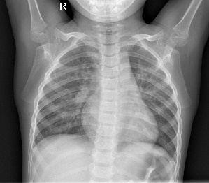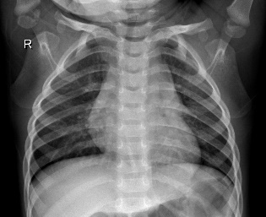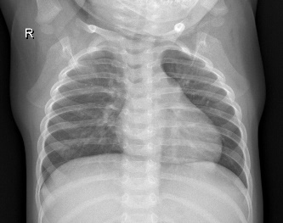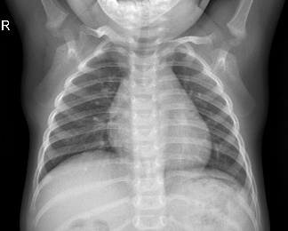

1. (b) (c) (d)

Figure 1: Sample Images without Pneumonia.

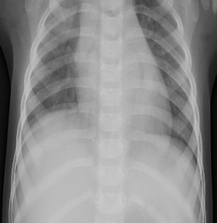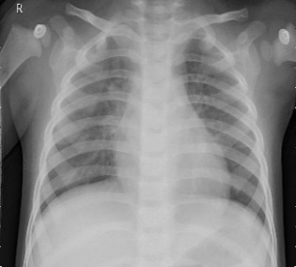

1. 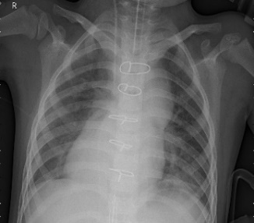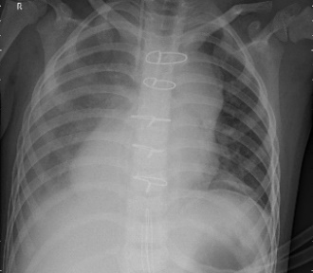 (b) (c) (d)

Figure 2: Sample Images with Pneumonia.

From the proposed model it is seen that the classifier sigmoid activation function is placed the end of the CNN model. The output now is converted to 1D and the process is called flattening where the output of the convolution layer is flattened to generate a feature vector for the dense layer. Next we used a dropout of size 0.5 and two dense layers of sizes 512 and 1 respectively with a RELU between them.

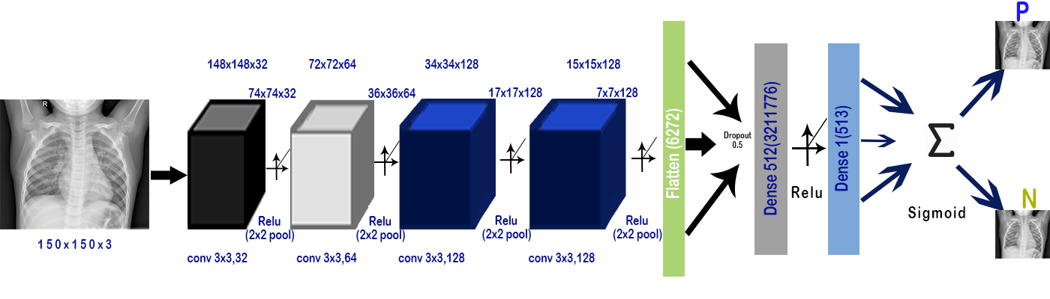

Figure 3. Proposed CNN model for classification

|  |  |  |
| --- | --- | --- |
| Layer (Type) | Output Shape | Param # |
| conv2d_13 (Conv2D) | (None, 148, 148, 32) | 896 |
| max_pooling2d_13 (MaxPooling) | (None, 74, 74, 32) | 0 |
| conv2d_14 (Conv2D) | (None, 72, 72, 64) | 18496 |
| max_pooling2d_14 (MaxPooling) | (None, 36, 36, 64) | 0 |
| conv2d_15 (Conv2D) | (None, 34, 34, 128) | 73856 |
| max_pooling2d_15 (MaxPooling) | (None, 17, 17, 128) | 0 |
| conv2d_16 (Conv2D) | (None, 15, 15, 128) | 147584 |
| max_pooling2d_16 (MaxPooling) | (None, 7, 7, 128) | 0 |
| flatten_4 (Flatten) | (None, 6272) | 0 |
| dropout_4 (Dropout) | (None, 6272) | 0 |
| dense_7 ( Dense) | (None, 512) | 3211776 |
| dense_8 (Dense) | (None, 1) | 513 |

Table 3: Model Summary

1. **Results:**

We conducted experiment on our proposed model 10 times to validate and evaluate effectiveness. Each process took approximately 4 hours. We repeatedly changed hyper parameters and parameters for the best possible result. We kept trying until we were satisfied with our result. This report consists of the most valid output we received.

We developed out model and tested it on a small dataset of 5200 images. The whole dataset was divided into two classes pneumonia and normal. We used deep convolution neural network to obtain the output shown in Figure 4. The final results are training loss = 0.0556, training accuracy = 0.9802, validation loss = 0.034 and validation accuracy = 0.9887.

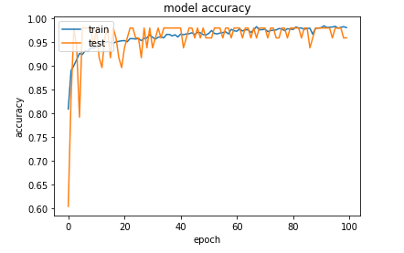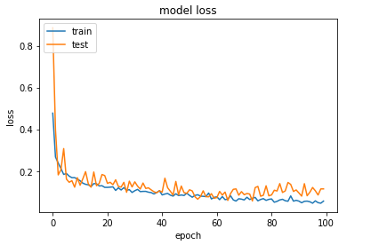

Figure 4: Performance of the classification model on 150x150x3 image size

|  |  |
| --- | --- |
| True-Positive : 522 | False-Positive : 0 |
| False-: Negative 18 | True-Negative : 560 |

|  |  |  |  |  |
| --- | --- | --- | --- | --- |
|  | Precision | Recall | F1-score | Support |
| pneumonia | 0.97 | 1.00 | 0.98 | 560 |
| normal | 1.00 | 0.97 | 0.98 | 540 |
| accuracy |  |  | 0.98 | 1100 |
| Macro avg | 0.98 | 0.98 | 0.98 | 1100 |
| Weighted avg | 0.98 | 0.98 | 0.98 | 1100 |

Table 4: Confusion matrix

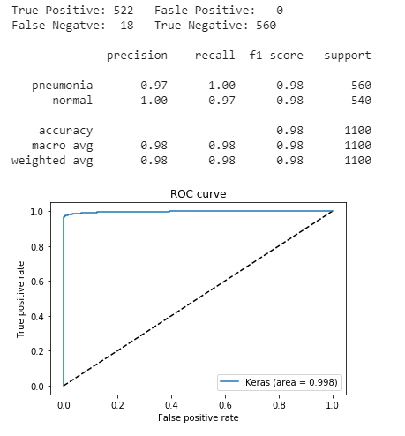

Figure 5: ROC curve

Here we used different sizes of images to test our model as CNN framework always requires images with fixed sizes. We reshaped our x-ray images in 100x100x3, 150x150x3, 200x200x3, 250x250x3 and 300x300x3 sizes. Each took almost 4 hours to train. To evaluate and validate the effectiveness of the proposed architecture we obtained the confusion matrix and ROC curve for all the mentioned image sizes. The performance of 150x150x3 are shown in Table 4 and Figure 4, 5.

From the repeated experiment we noticed the larger the image size is the lesser the validation accuracy was obtained. And finally we got the best result when image size 150x150x3 was used. But other changes were very near. No significant change was noticed during multiple experiments. With 150x150x3 we obtained 98 percent validation accuracy with a minimal loss of 0.034.

1. **Discussion**

We constructed an architecture with chest X-ray images taken from frontal views to detect pneumonia.

|  |  |  |
| --- | --- | --- |
| Data Size | Training Accuracy | Validation Accuracy |
| 100 | 0.9701 | 0.9754 |
| 150 | 0.9802 | 0.9887 |
| 200 | o.9687 | 0.9703 |
| 250 | 0.9543 | 0.9634 |
| 300 | 0.9502 | 0.9630 |
| Average | 0.9647 | 0.9721 |

Table 5: Performance of the model on different image sizes

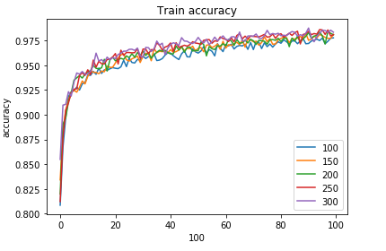

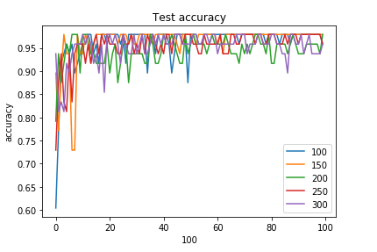

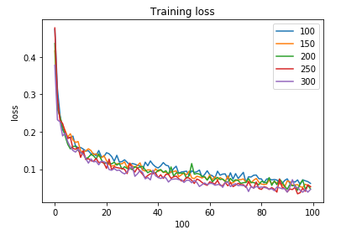

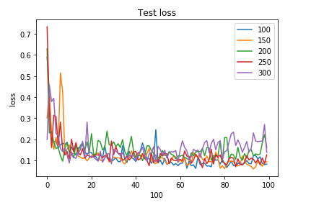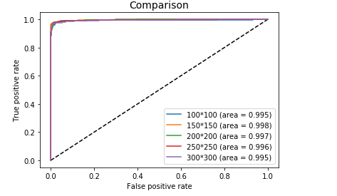

Figure 6: Comparison of performances on all mentioned data sizes

The design begins with transforming X-ray images into smaller sizes. Then for detecting and classifying pneumonia we used convolution neural network framework, which extracted features from the images. After couple of experiments we obtained our expected output which was higher than the other approaches. We repeated our experiment several times to check the accuracy and every time we received the same result. For validating the performance we trained the model on different sizes of x-ray images and obtained similar results.

We believe, if we have huge access to data and can train the model with radiological data from patients and normal people from different places, we could bring significant changes to this model.

1. **Conclusion:**

We have exhibited a model to segregate positive or negative pneumonia data from a number of X-ray images. Our model is distinguishable from other models that depend mainly on transfer learning approach. This model also can be used in detecting and classifying X-ray images consisting of lung cancer and pneumonia. We hope this model will be very useful in rural areas where expert doctors are not available and people are deprived of medical help.

**Data Availability:**

The data used in this study to support the findings are included within the article.

**Conflict of Interest:**

The authors declare that there are no conflicts of interest regarding the publication of this paper.

**References:**

[1] <https://www.icddrb.org/news-and-events/press-corner/media-resources/pneumonia-and-other-respiratory-diseases>

[2] World Health Organization, Household Air Pollution and Health [Fact Sheet], WHO, Geneva, Switzerland, 2018, <http://www.who.int/newa-room/fact-sheet/detail/household-air-pollution-and-health>

[3] Pneumonia mortality and healthcare utilization in young children in rural Bangladesh: a prospective verbal autopsy study, <https://tropmedhealth.biomedcentral.com/articles/10.1186/s41182-018-0099-4>

[4] Pneumonia: The forgotten killer of children. Geneva, UNICEF/WHO, 2006.

[5] https://www.icddrb.org/news-and-events/press-corner/media-resources/pneumonia-and-other-respiratory-diseases

[6] https://www.dhakatribune.com/bangladesh/2019/11/13/report-pneumonia-kills-4-children-every-3-hours-in-bangladesh

[7] Kaggle. RSNA Pneumonia Detection Challenge. [www.kaggle.com/c/rsna-pneumonia-detectionchallenge/data](http://www.kaggle.com/c/rsna-pneumonia-detectionchallenge/data)

[8] E. Andre, K. Brett, A Roberto et al., “Dermatologist-level classification of skin cancer with deep neural networks,” Nature, vol. 542, no. 7639, pp. 115–118, 2017.

[9] M. Grewal, M. M. Srivastava, P. Kumar, and S. Varadarajan, “Radiologist level accuracy using deep learning for hemorrhage detection in CT scans,” 2017, [http://arxiv.org/abs/1710. 04934](http://arxiv.org/abs/1710.%2004934).

[10] R. Pranav, Y. H. Awni, H. Masoumeh, B. Codie, and Y. N. Andrew, “Cardiologist-level arrhythmia detection with convolutional neural networks,” 2017, http://arxiv.org/abs/ 1707.01836.

[11] G. Varun, P. Lily, C. Marc et al., “Development and validation of a deep learning algorithm for detection of diabetic retinopathy in retinal fundus photographs,” JAMA, 2017, vol. 316, no. 22, pp. 2402–2410.

[12] Detecting Pneumonia in Chest X-Rays with Supervised Learning Benjamin Antin, Joshua Kravitz, and Emil Martayan. <https://pdfs.semanticscholar.org/bbc7/49a5c9139dc642a78647c1dfed1df71bba07.pdf>

[13] CheXNet: Radiologist-Level Pneumonia Detection on Chest X-Rays with Deep Learning Pranav Rajpurkar, Jeremy Irvin, Kaylie Zhu, Brandon Yang, Hershel Mehta, Tony Duan, Daisy Ding, Aarti Bagul, Robyn L. Ball, Curtis Langlotz, Katie Shpanskaya, Matthew P. Lungren, Andrew Y. Ng

[14] Comparison of Deep Learning Approaches for Multi-Label Chest X-Ray Classification Ivo M. Baltruschat, Hannes Nickisch, Michael Grass, Tobias Knopp & Axel Saalbach.

[15] Guan, Q.; Huang, Y.; Zhong, Z.; Zheng, Z.; Zheng, L.; Yang, Y. Diagnose like a Radiologist: Attention Guided Convolutional Neural Network for Thorax Disease Classification. arXiv. 2018. Available online: https://arxiv.org/abs/1801.09927v1 (accessed on 17 June 2018)

[16] Rodrigues, M. B., Nobrega, R. V. M. D., Alves, S. S. A., ´ Filho, P. P. R., Duarte, J. B. F., Sangaiah, A. K., and Albuquerque, V. H. C. D. (2018). Health of things algorithms for malignancy level classification of lung nodules. IEEE Access, 6:18592–18601.

[17] Santosh, K. C. and Antani, S. (2018). Automated chest x-ray screening: Can lung region symmetry help detect pulmonary abnormalities? IEEE Transactions on Medical Imaging, 37(5):1168–1177.

[18] Classification of Images of Childhood Pneumonia using Convolutional Neural Networks- A. A. Saraiva1 a , N. M. Fonseca Ferreira2,3,4 b , Luciano Lopes de Sousa5 c , Nator Junior C. Costa5 d , Jose Vigno Moura Sousa ´ 5,6 e , D. B. S. Santos5 f , Antonio Valente2,7 g and Salviano Soares

[19] <https://www.kaggle.com/paultimothymooney/chest-xray-pneumonia>